An artist is creative, working in a wide range of
disciplines including painting, writing, poetry, music, performance art and more.
Gloversville offers a variety of opportunities for artists, as well as venues to explore for those appreciating the craft.

PRODUCTIONS
Trust Your Gut Productions (TYGP), founded in 2009 by Michael Maricondi and the late Carol-Anne Gaetano, began by addressing bullying through youth musicals. After a hiatus, TYGP re-emerged in 2023, based in Gloversville, New York, producing diverse theatrical works and collaborating on community initiatives like "Prevention in Acti-ion," which tackled the opioid crisis. TYGP continues to develop new productions and fosters an inclusive space for artists. For more information, contact 203-314-7729 or trustyourgutproductions@gmail.com.

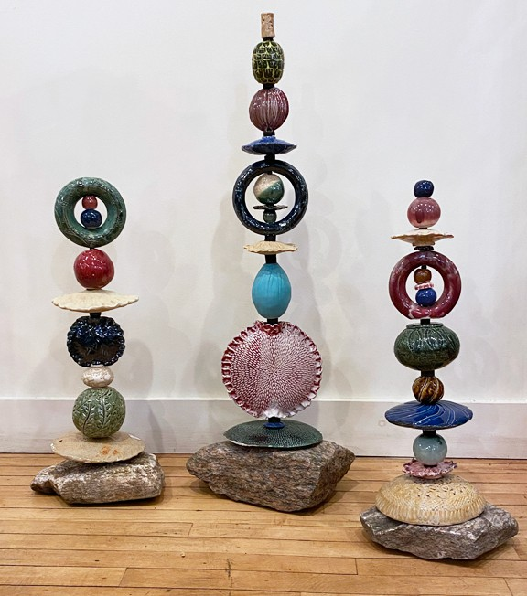
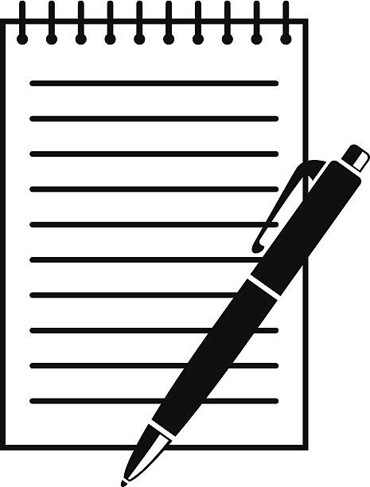
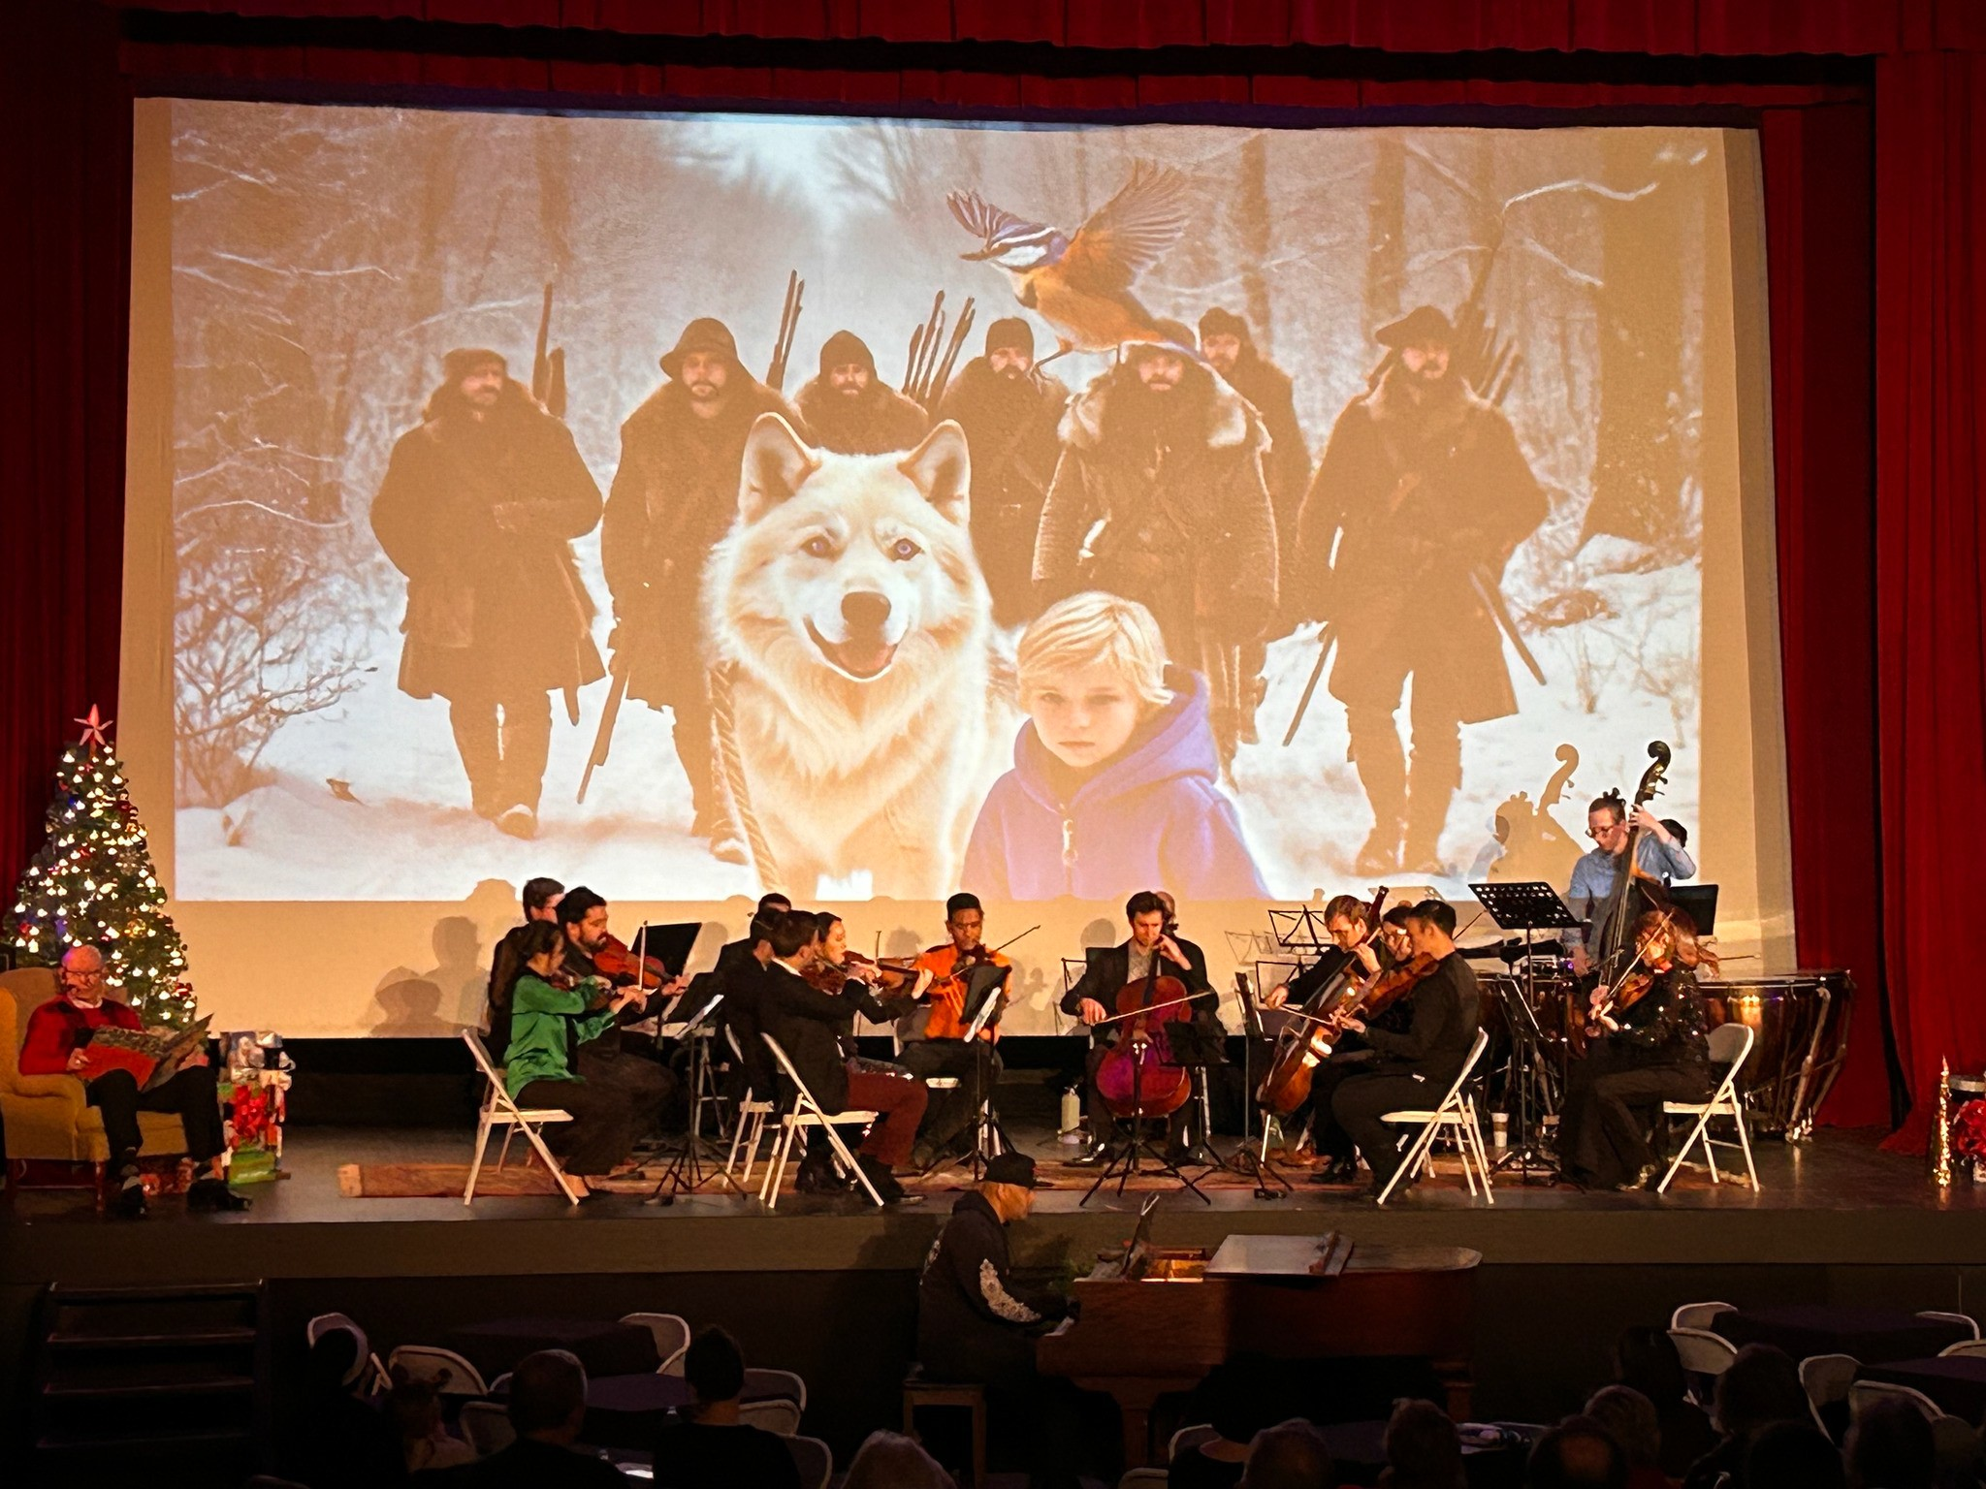
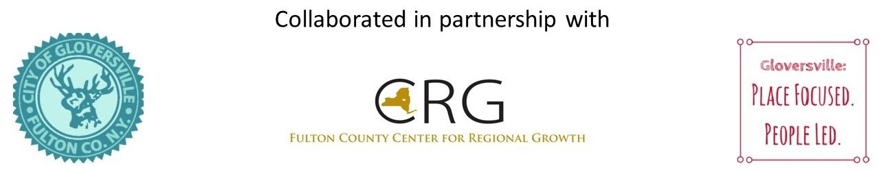
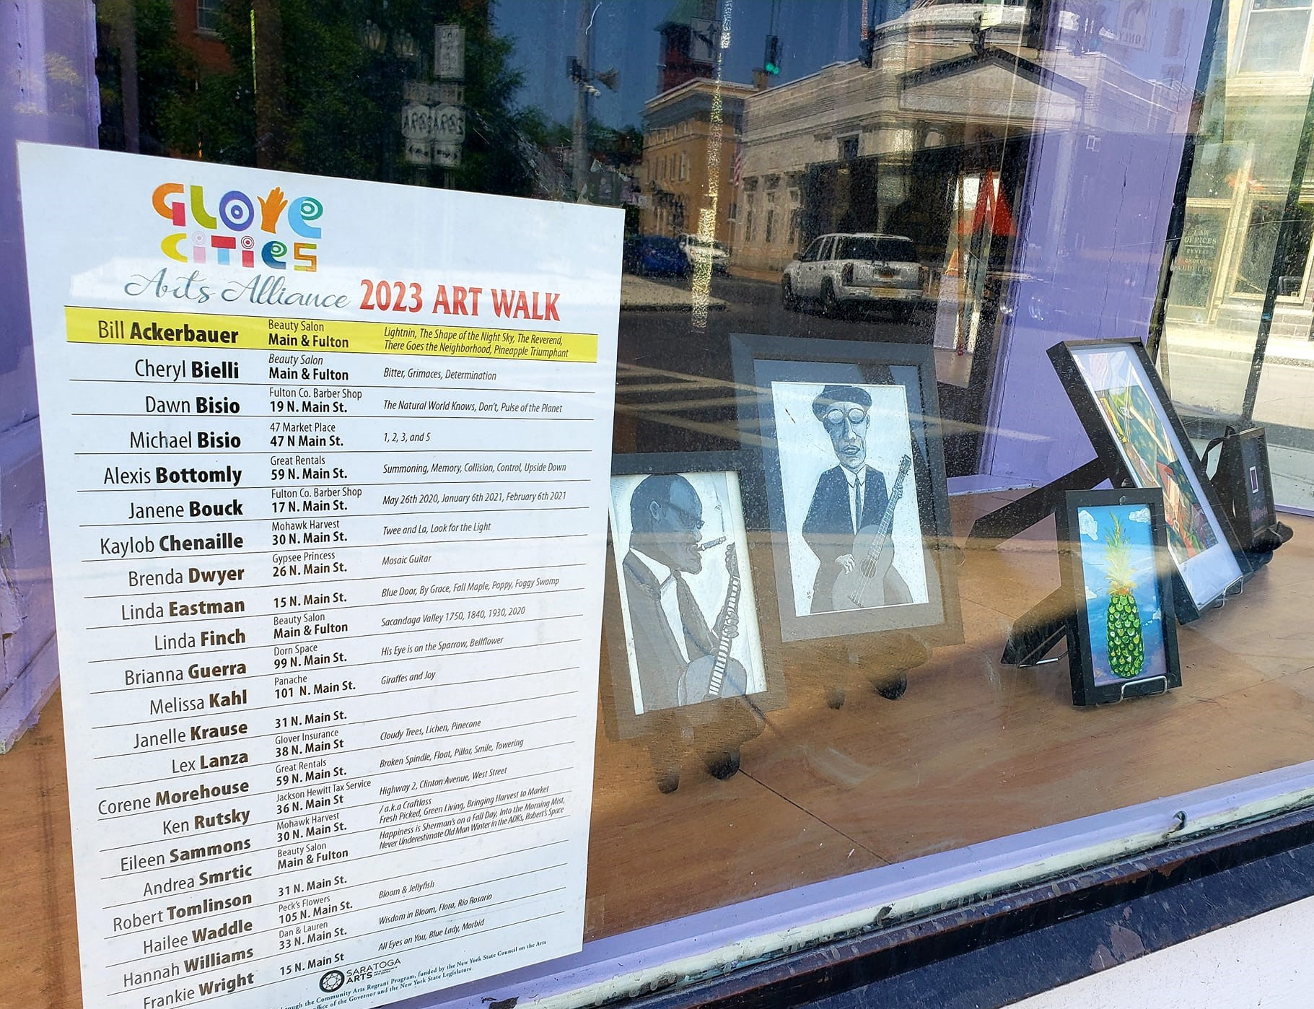
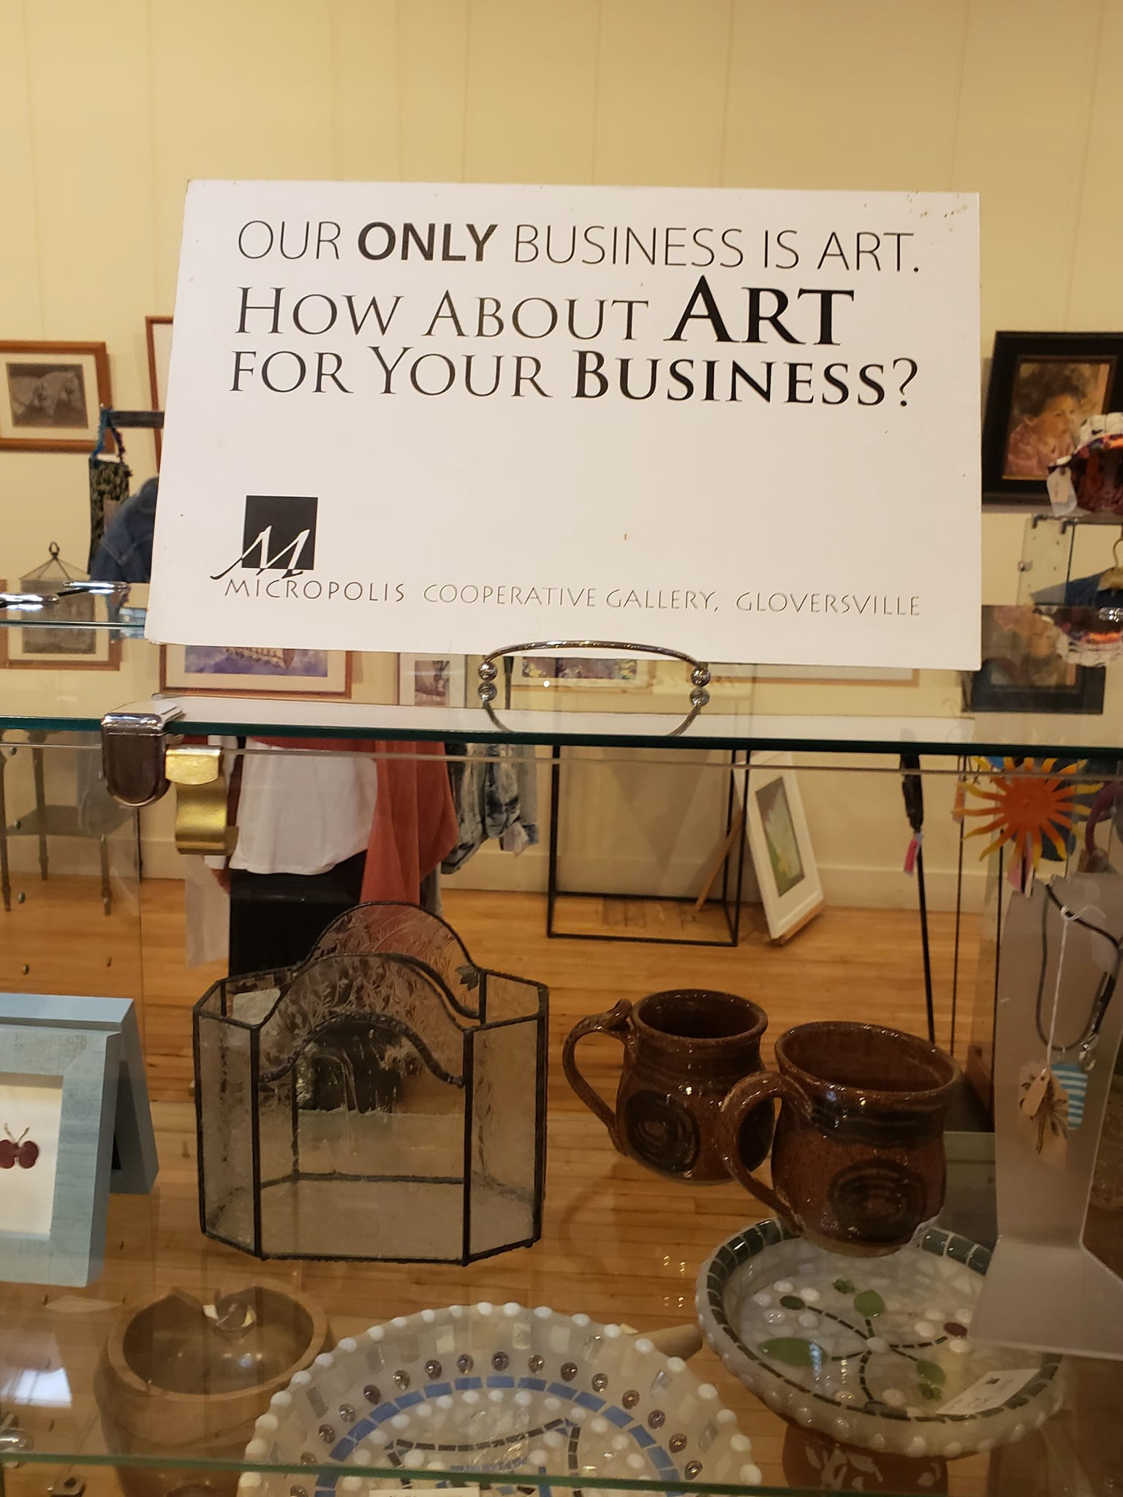
Discover the arts and entertainment in Gloversville, and join us with sharing your imagination and creativity.

"Art evokes the mystery without which the world would not exist."
- Rene Magritte

"Creativity is contagious, pass it on."
- Albert Einstein
DISCOVER - IMAGINE - CREATE

DOWNTOWN GLOVERSVILLE

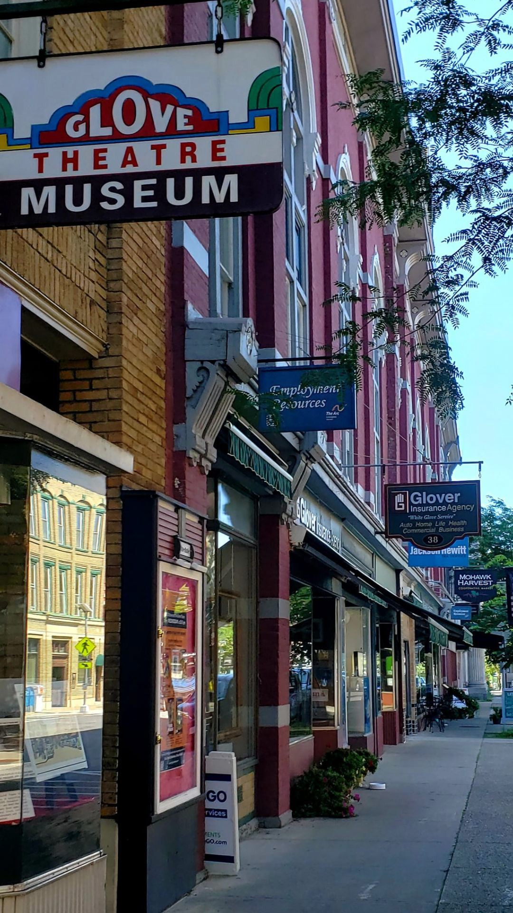
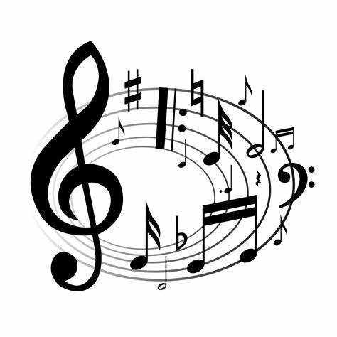
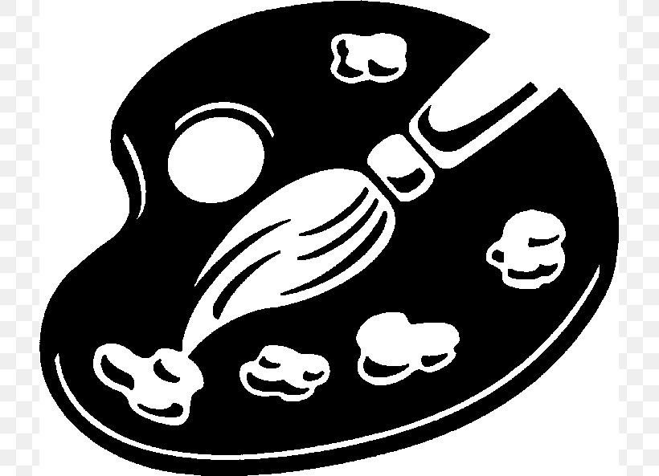
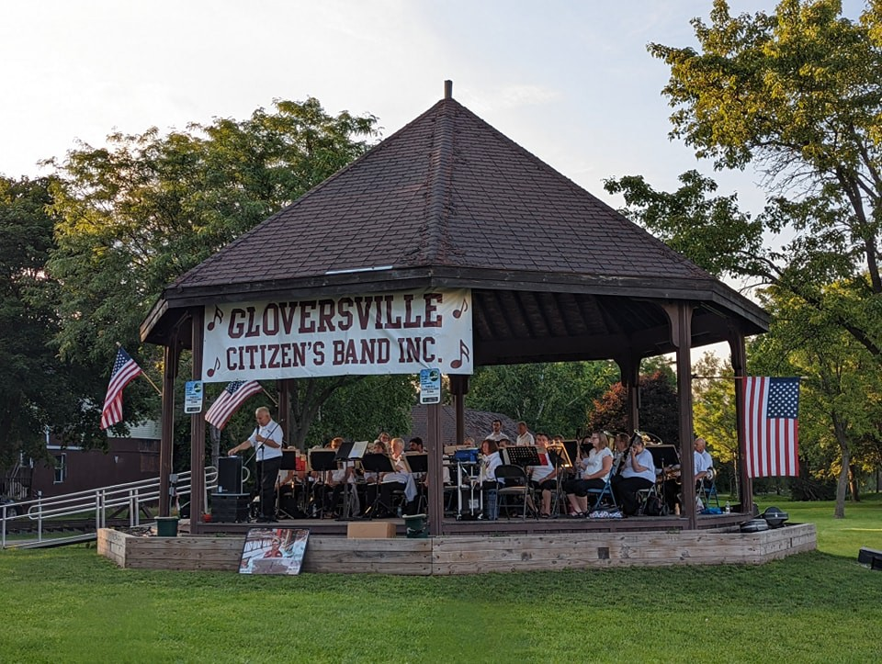
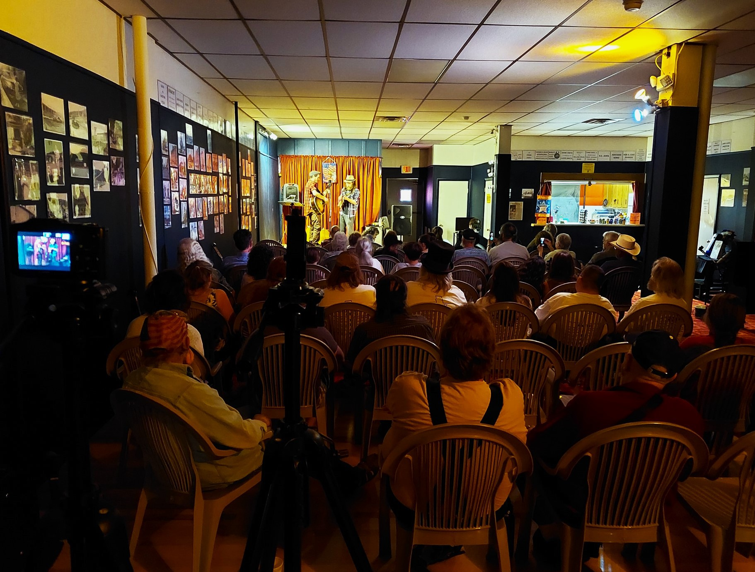

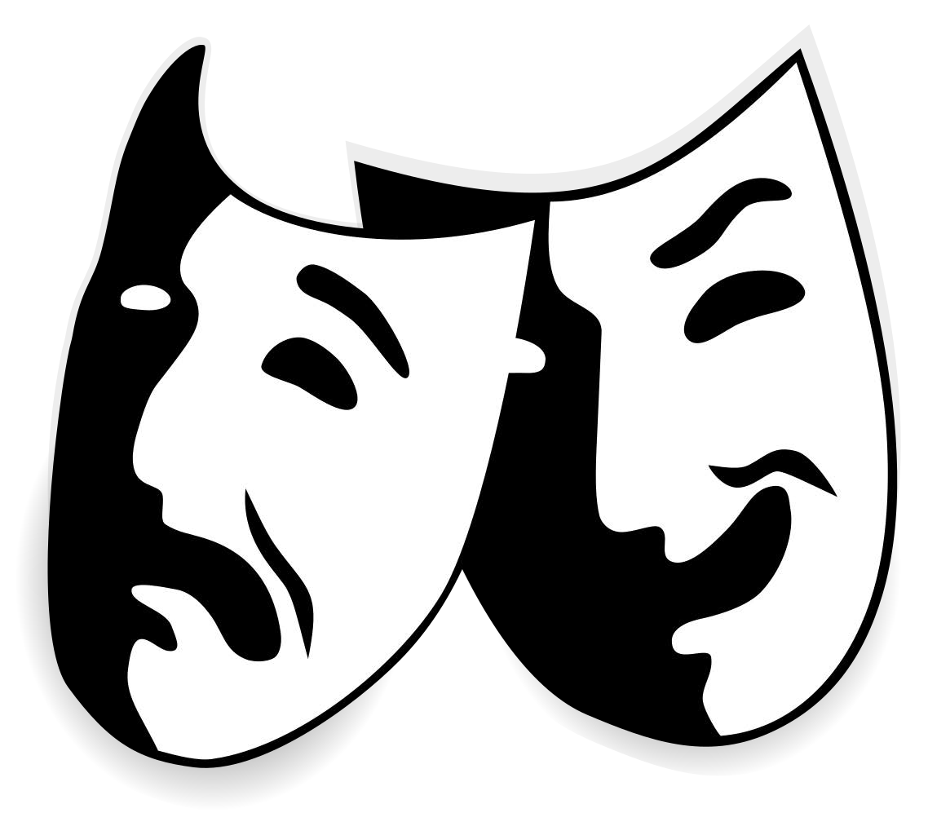
PERFORMANCE ART
Glove Theatre, 42 N. Main St., entertains audiences throughout the year with music performances, community theater, comedy, holiday shows and more. To learn how to get involved with the Glove Theatre, visit theglovetheatre.com or email theglovetheatre@gmail.com.

Dorn Space, 99 N. Main St., is a creative haven for performing arts and promotes innovative material by original artists. A family-friendly entertainment venue, upcoming events can be found at https://dornspace.tv. For more information, call (838) 202-4425 or email dornspace@gmail.com.

VISUAL ART
Micropolis Cooperative Inc. hosts a gallery that is located at
30 N. Main St. and celebrates artists that work in a wide range of media and styles, including jewelry, paintings, drawings, photographs, fiber art, mixed media, glass, digital art, pottery, woodland collages, baskets, and fine arts card. The gallery also hosts several “Meet the Artists Receptions” throughout the year. To learn more, visit www.facebook.com/ MicropolisGallery

Glove Cities Arts Alliance promotes artists and administers the Glove Gallery exhibit space located at Glove City Lofts,
52 Church St. Email glovecitiesarts@gmail.com or visit www.facebook.com/glovecitiesarts for information on their events that include concerts, open mic nights and exhibits. They are accepting new members.

MUSIC MAKERS
Gloversville Civic Band consists of musicians from the area and performs concerts in the summer at Trail Station Park. This long-standing non-profit musical ensemble in Fulton County, New York, has origins tracing back to the 19th Century. Every summer, the band performs a series of free, public outdoor concerts, typically hosted on Wednesday evenings at Trail Station Park, featuring a mix of traditional, classical, and popular American wind band repertoire Visit facebook.com/GloversvilleBand.

